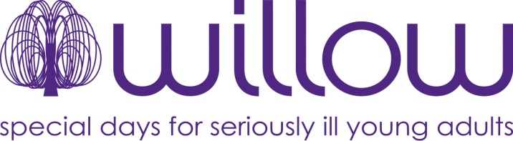

Boost your donation by 25p of Gift Aid for every £1 you donate

Gift Aid is reclaimed by Willow from the tax you pay for the current tax year.
Your address is needed to identify you as a current UK taxpayer.

In order to Gift Aid your donation you must tick the box below:

Please treat all donations I make in the future or have made in the past 4 years to Willow as
Gift Aid donations.

I am a UK taxpayer and understand that if I pay less Income Tax and /or Capital Gains Tax than the amount of Gift Aid claimed on all my donations in that tax year it is my responsibility to pay any difference.

My Details

Title ____________ First name or initial(s) _______________________________________

Surname ___________________________________________________________________

Full Home address __________________________________________________________

___________________________________________________________________________

___________________________________________________________________________

Postcode _____________________ Date _______________________________________

Please notify the charity if you:

- want to cancel this declaration
- change your name or home address
- no longer pay sufficient tax on your income and/or capital gains

If you pay Income Tax at the higher or additional rate and want to receive the additional tax relief due to you, you must include all your Gift Aid donations on your Self Assessment tax return or ask HM Revenue and Customs to adjust your tax code.
Willow, Gate House, Fretherne Road, Welwyn Garden City, Hertfordshire AL8 6NS
T: 01707 259 777 F: 01707 259 289 E: info@willowfoundation.org.uk W: willowfoundation.org.uk
Willow foundation is a registered charity in England and Wales No. 1106746 and a registered charity in Scotland No. SC045811. It is also a company limited by guarantee No. 5207070.
Registered in England and Wales at the above address

