
Padel With Purpose
Willow Winter Tournament 2026
Thursday 19th November, Padel Zone Hitchin
Sponsorship package


Life for people aged 16 to 40 should be about adventure, independence and connecting with others. But for those who are seriously ill, it’s often dominated by medical appointments and constant worry about the future.

We encourage people aged 16 to 40 who are seriously ill to tell us about their passions, hopes for the future and what matters to them most. Our dedicated team goes above and beyond to craft unforgettable moments as unique as the person who’ll enjoy it.

From the moment Willow’s personalised and unforgettable experiences are in the diary, the young adults and their families that we support have something positive and exciting to focus on at a time when their lives have been consumed by devastating illness and a harsh medical regime.

Sadly, even with treatment, many young adults will die of their illness. We can’t change that, but we can give them precious experiences to share with their loved ones that bring joy when it seems so far away.

We are incredibly proud to have delivered more than 24,500 Special Days across the UK to date. With an average of four attendees at each experience this has resulted in 96,000 people positively impacted by our services. Our commitment and dedication is driven by the belief that every young person facing serious illness deserves moments of joy, connection, and normality, even in the most difficult of circumstances.


Willow was founded in 1999 by former Arsenal goalkeeper and TV presenter, Bob Wilson and his wife Megs, as a lasting memorial to their daughter Anna, who died of cancer aged 31. The inspiration for Willow came from Anna’s determination to live every moment to the full, despite the most difficult of circumstances.

“Anna’s love of life and her own ‘special days’ taught us that quality of life and quality of time is so very important. Laughter and smiles go a long way to repairing so much of what is damaged by serious illness.”
Bob and Megs Wilson,
Willow Co-Founders & Life Presidents

Sandra’s Special Day

Sandra, 21, after losing her dad to Covid and receiving the devastating cancer diagnosis, Sandra wanted nothing more than to be 'a normal 21-year-old', experiencing life as it should be. To see Maluma at her first-ever concert for her Special Day was a dream come true!

"My life since I found out about my cancer has changed completely. All my reality has now become hospitals and appointments. Currently, I'm not working, making our situation very difficult financially. My partner and I really wanted to go to the Maluma gig ever since we knew about it, but we decided not to because we have different spending now. Then I found Willow, and they made it happen for us. Life with cancer is really hard itself but has all the additional aspects such as financial and emotional - it took away from me who I really was- just a normal, happy girl who wanted to experience life fully
Last year my Dad went to the hospital with Covid (and some other health conditions), and he passed away. That was a very hard year for me and all my family.
All my experience since contacting Willow, through speaking with my coordinator, getting all instructions and then going on my Special Day, was amazing. Everything was planned perfectly, and contact with those helpful people even on the day of the gig itself.
Thanks to Willow, I had at least one day when I could forget about all of this nightmare and once again just be a young, happy girl who went to a concert by the guy who she loves to listen to. I wanted just one day to forget about what happened to me and what huge impact it has had on me and my partner.
I would say I understood that no matter what my diagnosis is, my life is still going on, and I won't change my health, but at least what I can do is enjoy my time here and let myself forget sometimes about everything. Just be me and do what makes me feel amazing, and catch those moments.
I cannot be more grateful for my Special Day experience. It was the first concert in my life and for sure was the best one; my dream came true on my Special Day thanks to Willow."

Service Types

Willow is open to all 16-40 year olds in the UK being treated for a life-threatening illness. We do not receive government funding and are totally reliant on the generosity of individuals, companies, trusts and foundations to fund our work.
We offer a range of experiences to suit everyone, including:

Special Days out: a tailor-made experiences, which can be a day trip or include an overnight stay.

Special Breaks: a longer break which could include a holiday park or self-catering accommodation.

Special Days at home: bringing the Special Days experience to your own home or garden.

Special Treats: A luxury box filled with gifts and tailored to your individual needs which is delivered directly to your door.

Total number of beneficiaries supported

24,554*

*as at 21 July 2026

Working in Partnership
Willow works in partnership with many companies and local businesses to help fund Special Days, Treats and Breaks. Without this support, Willow would not be able to continue delivering more than 1400 Special Days and treats every year for young adults living in the UK facing the reality of serious illness.

By sponsoring Padel With Purpose event your company could:

- Benefit from a positive association with a well known and respected charity
- Generate positive PR
- Enhance the delivery of your company's corporate social responsibility objectives
- Increase staff / customer loyalty and trust
- Be positioned as an organisation that supports good causes

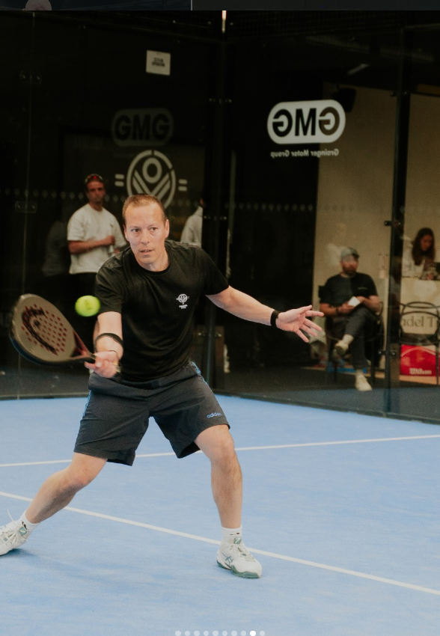

As well as helping to do good, supporting a charity can help your business in many ways. Companies that are able to demonstrate a social conscience, a commitment to making a positive contribution to the world and who can show that this is a core value of their business will be rewarded.

Research shows that when faced with a choice between two companies that offered products a service for the same price, 82% of UK consumers said their decision would be affected by whether a company engaged with Charities.

*Foresters (2013) survey 1’100 people in the UK

Padel With Purpose Sponsorship Package

Following the success of Willow’s first Corporate Padel Tournament, we’re bringing the action to Hertfordshire with our Padel with Purpose competition.

Taking place at Padel Zone Hitchin, the event will bring together local businesses, community groups and their teams for a morning of competitive padel, networking and fun in support of our charity.

Whether you’re new to padel or already a regular on the court, this is a great opportunity to get your colleagues together, meet other local businesses and enjoy a fun-filled tournament — all while supporting a great cause.

Expect plenty of friendly competition and tournament action, followed by lunch provided by the incredible Chicken George as we round off the event and celebrate the winners.
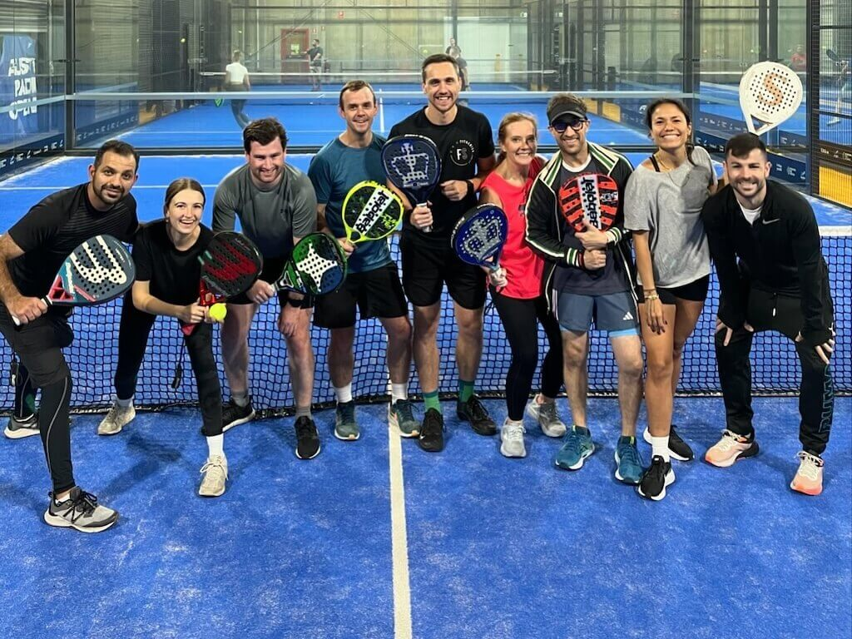
The tournament provides a unique PR and marketing opportunity to promote your business in association with our charity to local people of Hitchin and Hertfordshire.

Sponsor benefits:

Online benefits

- Your logo featured on dedicated Padel With Purpose webpage with hyperlink to sponsor website
- Mentions on official Willow social media posts (pre and post event) giving your company the chance to be seen to a nationwide audience
- Your company logo featured on the event poster which will be distributed virtually and physically in the build-up to the event
- Willow will mention your company as a sponsor in any press releases or media coverage the event recieves

Inclusion in the event

- 2 complimentary tickets for the event for the team
- Sponsor acknowledgement during the event from event hosts
- Banner placement in the bar area of the venue which will be the main HQ for the event throughout the day
- Your company logo featured on the multiple TV screens at the venue on the day
- Opportunity to give out an award at the end of the event
- Your branded merchandise can be displayed at the check in desk to be viewed when each team arrives

Additional Benefits
- Future partnership opportunities with Willow within our campaigns and events programme.

Cost of sponsorship – £500

What our sponsors say:

“We believe in the power of experiences and the positive effect they can have on all us. That’s why we work with Willow.”
Rhys at Buy A Gift
"The team at Wrights are proud to support Willow and we have all loved getting involved in helping out with supporting their fundraising events. The work that Willow does is so valuable and we are thrilled that we are able to contribute to raising funds for such a worthwhile cause.
Melvin at Wrights Estate Agents

To discuss this sponsorship, please contact:

Harry Folgate & Poppy Mason
Willow Community Fundraising team
Email: fundraising@willowfoundation.org.uk

